MEDIA CONTACT: FOR IMMEDIATE RELEASE
Nina Thompson JULY 8, 2024
619-372-0916 cell
nthompson@sdhumane.org

Mountain Lion Hit by Car Returns Home to Wild
Cub with severely fractured leg recovers after surgeries at San Diego Humane Society’s Ramona Wildlife Center

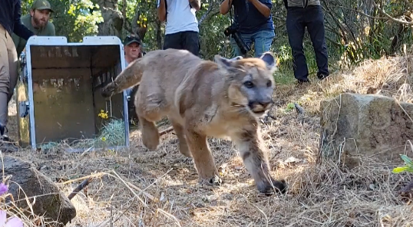
RAMONA, CA — A young male mountain lion is back in the wild where he belongs after spending seven months at San Diego Humane Society’s Ramona Wildlife Center. The cub was released by the California Department of Fish and Wildlife (CDFW) on Wednesday, June 26, 2024, in Ventura County. Before release, he was outfitted with a satellite GPS collar for tracking to help ensure his future health and wellbeing.

The five-month-old mountain lion first came to San Diego Humane Society on Thanksgiving Day, Nov. 23, 2023. Presumably, he had been hit by a vehicle the night before Thanksgiving and found on the side of a road in Simi Valley. Local animal services alerted CDFW, who quickly transported the cub to Santa Clarita, where veterinarians provided initial medical support.

X-rays at San Diego Humane Society showed the mountain lion had a fractured hind leg. He was treated for dehydration, malnourishment and the veterinary team carefully repaired the animal’s left tibia, using a metal plate and 10 screws to realign the bones. For the next three weeks, the mountain lion was monitored via cameras in an indoor hospital enclosure, limiting human interaction and movement that could risk damage to the surgery site. Then veterinarians performed a second surgery to revise the placement of the screws. The cub needed additional time to recover but was able to move to an outdoor enclosure for continued rehabilitation in mid-December.

During a sedated recheck on Jan. 26, 2024, veterinarians confirmed the fracture was healing well and the mountain lion was gaining strength. “This patient was a very special case, because his surgeries involved a unique collaboration between Project Wildlife veterinarians and shelter veterinarians,” said Jon Enyart, DVM, Senior Director of Project Wildlife at San Diego Humane Society. “Being a teaching institution, we seize opportunities to share our skills across our wildlife and companion animal sides, ensuring every patient gets the highest quality medical care.”

Mountain lions are apex predators, so it was crucial for this cub to be fully recovered and able to survive and hunt on his own. In the wild, mountain lion cubs may stay with their mothers up to 26 months, but usually separate after about 15 months.

San Diego Humane Society’s Project Wildlife program is the primary resource for wild animal rehabilitation and conservation education in San Diego County. Each year, the organization gives more than 10,000 injured, orphaned, and sick wild animals a second chance. At the Ramona Campus, which they have been operating since 2020, SDHS specializes in caring for native apex predators and birds of prey, including hawks, owls, eagles, coyotes, bears, bobcats and, under special case-by-case authorization, mountain lions.

Photos/b-roll of mountain lion’s return to the wild for media use can be downloaded here:
https://spaces.hightail.com/space/RZuGAXZjuJ
Photo/video credit: Please check individual files!
SDHS=San Diego Humane Society
CDFW=California Department of Fish and Wildlife

Photos/b-roll of mountain lion’s treatment/recovery while at the Ramona Wildlife Center for media use can be downloaded here:
https://spaces.hightail.com/space/d7vtjEHVQ3
Photo/video credit: San Diego Humane Society

Video clips of the mountain lion in habitat during recovery at the Ramona Wildlife Center for media use can be downloaded here:
https://spaces.hightail.com/space/fslO57orge
Photo/video credit: San Diego Humane Society

About San Diego Humane Society
San Diego Humane Society’s scope of social responsibility goes beyond adopting animals. We offer programs that strengthen the human-animal bond, prevent cruelty and neglect, provide medical care, educate the community and serve as a safety net for all pet families. Serving San Diego County since 1880, San Diego Humane Society has campuses in El Cajon, Escondido, Oceanside, Ramona and San Diego. For more information, visit sdhumane.org.

###

